Dental About Me - Patient Profile
You can add a photo here
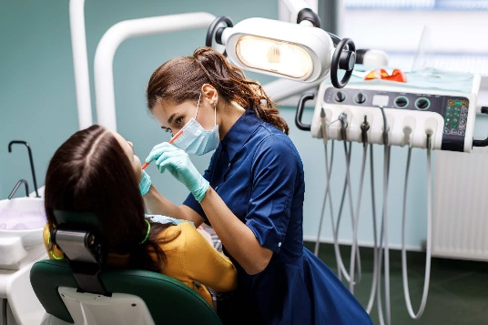
This Dental About Me – Patient Profile is recommended for you to share with your dental clinic, oral health professionals or relevant others. This can be shared with all the clinical team, so they know how to best connect with you on each visit by understanding your communication and support needs.
It is recommended that this Patient Profile is reviewed yearly to make any changes or updated as changes occur.
IMPORTANT: This document contains confidential information and will not be used or distributed to others without specific consent from the patient.
My patient information
My name:
Please tick: ☐ Male ☐ Female ☐ Other
Please tick – My pronouns: ☐ She / her ☐ He / him ☐ They / them ☐ Other
Date of birth (dd/mm/yyyy):
Address:
Phone number:
Please tick – My main language spoken at home is:
Do you need another person to assist you to communicate? ☐ Yes ☐ No
☐ Key worker ☐ House supervisor ☐ Interpreter ☐ other (e.g. parent, sibling)
Please tick – I identify as Aboriginal and or Torres Strait Islander: ☐ Yes ☐ No
Please share – My cultural and spiritual needs are:
Please share – My primary disability is:
Please share – My other disabilities are (if required):
Other information you may wish to share:
This template was created by the Supporting People with an Intellectual Disability to Access Health (SPIDAH) project, at the Western Victoria Primary Health Network. Last reviewed March 2024.
Please share – My key health information is:
Document | Number | Name | Expiry date | Optional: add image of card
Health Care Card
Pensioner Concession Card
Veterans Card
NDIS Plan
Other

My consent
I, (patient name) _____________________________ provide my consent for this About Me – Patient Profile to be kept on file at (name of clinic):
IMPORTANT: Adults are presumed to have decision-making capacity unless there is evidence to the contrary. For further information: Patient capacity to consent - Office of the Public Advocate
Note: You may have a key person or supporter in your life who knows you best. This may be a key worker, house supervisor or other (advocate, parent, sibling etc). Please provide their name and details so we can talk directly to them, and they can give us information on your behalf.
Name (supporter name):
Their relationship to me is:
Their phone number:
This form was completed on (date) (dd/mm/yyyy):
Name (supporter name):
Their relationship to me is:
Their phone number:
This form was completed on (date) (dd/mm/yyyy):
Decision-making
Note: A ‘medical treatment decision maker’ is someone who has legal authority to make medical treatment decisions for you under the Victoria’s Medical Treatment Planning and Decisions Act 2016.
Please tick – I have a legal Medical Treatment and Decision Maker: ☐ Yes ☐ No
If yes, their name is:
Their relationship to me is:
Their phone number is:
How I communicate
For example, I use a communication device / aids. I can take 30 seconds to think and answer questions. How I communicate pain.
Please share – The way I communicate is:
Optional: Record a short video and add the link here:
How you should communicate to me
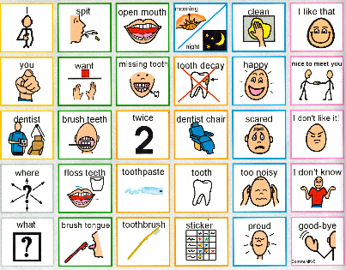
Please tick and share – I need health professionals to communicate with me by:
☐ Talk slowly and use easy words.
☐ Use pictures and videos to explain things, so I can
look at them again later.
☐ Give me information to take home (preferred format
below).
(☐ Text written on paper) (☐ Email) (☐ Audio) (☐ Video)
More information:
My appointment needs
Health professionals: Make sure you check what is the role of the support person.
The best time of day for my appointment: ☐ 9am-11.30am ☐1pm-4.30pm ☐ Other
Please tick and share – For my appointments I need:
☐ A phone call reminder for my upcoming appointment.
☐ An SMS reminder to my primary support person about my appointment.
☐ A longer time for my appointments to support my communication needs.
More information:
Dentist visit
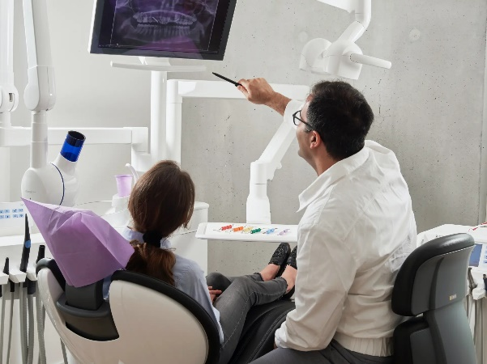
Have you been to the dentist before?
☐ Yes ☐ No
If yes, was the experience good or bad. Please explain.
Did you use a sedation program for dental care? ☐ Yes ☐ No
3 things to connect with me
For example, I have a dog named Larry. I like gardening. Please ask about my day.

3 things I do not like when I see a dental or oral health professional
For example, I do not like sitting in the waiting room – please let me wait in the car.

My Health Record
Please tick – I would like my health information added to My Health Record:
☐ Yes ☐ No
Office use only: If it has been more than 12 months it is preferable to re-confirm consent.

Other important information the dentist and oral health professional need to best support you

Accessibility support:
Do you need access support for the following?
☐ An accessible car park
☐ Ramp access
☐ Elevator required (difficulty with stairs)
☐ Appointments preferably on ground floor
Do you need a quiet space to wait for your appointment?
☐ Prefer to wait in car for appointment
☐ Separate waiting space in the clinic
☐ Dimmed lighting
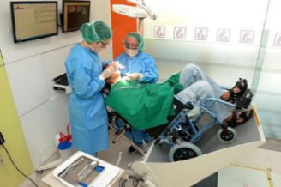
☐ Other
Do you use a wheelchair? ☐ Yes ☐ No
If yes, can you transfer to the dental chair for treatment?
☐ Yes ☐ No
If no, what supports do you need:
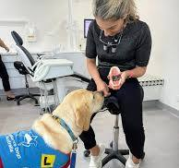
Do you have a service animal? ☐ Yes ☐ No
Will you need the service animal during treatment? ☐ Yes ☐ No
If yes, what do we need to know to support access?

This form continues on the next page.
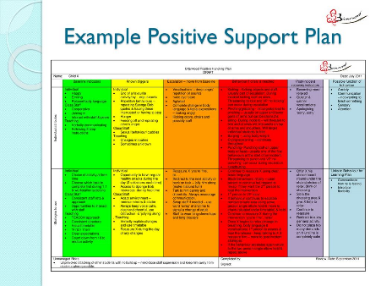
Behaviour support:
Do you have a behaviour support plan? ☐ Yes ☐ No
Do we need to modify your plan for your dentist visit?
☐ Yes ☐ No
What things do we need to know when you come to the dentist?
Consider:
Who is the best person to support you to the visit?
What role does the support person play? Eg. Bringing them to the appointment only, coming in the room, or other.
Any behaviours of concern or things we need to be aware of (mental health/sensory needs)?
Are there any triggers that we need to know about? Like words not to use, or other things that indicate will make you feel unsafe or uncomfortable.
What happens if you do become triggered?
What is in your plan that will help you gain control and relax again.
You may record a video to show us and we can put this on file.
Medication:
Are you on any medications? ☐ Yes ☐ No
If yes, please bring your up-to-date medicine list to the dentist.
Do you have any allergic reactions to medication that you cannot have that we need to be aware of? Please provide detail.

Did you know - Read the full fact sheet
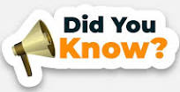
- Some medications can cause tooth damage.
- Some medications cause a condition called dry mouth, which significantly increases the risk of tooth decay.
- Tell your dentist about any prescription, non-prescription medications and recreational drugs you are taking.
- Smoking increases your risk of gum problems and cancers, including oral cancer.
- Drinking alcohol regularly can cause a dry mouth and tooth erosion.

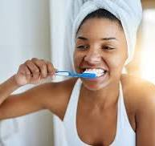
Oral health habits:
Do you brush your teeth once or twice a day? ☐ Yes ☐ No
Can you do this independently? ☐ Yes ☐ No
If no, how are you supported?
Because of your disability is it difficult to brush your teeth or get support to brush your teeth properly? ☐ Yes ☐ No (Please share this information with the dentist and ask if they have any tips on how to make this easier)
Is the area around your mouth sensitive to touch? ☐ Yes ☐ No
If yes, what are the considerations or the ways to support you? (Eg. Explain step by step instructions):
Do you have any illnesses that we need to be aware of? (For example, cancer and any treatments as they can impact on bone density and teeth.)
Important: Always bring someone that knows you best to these appointments.
Diet plays an important role in good oral health. Please help us understand your diet a little better. Do you have:
☐ A typical diet
☐ A modified diet
☐ Swallowing and aspiration issues
☐ Self-feeding
☐ Assisted feeding
☐ Need to feed at certain times
See videos below for more tips.

Things to consider:
- When was the last time the person had an annual health assessment.
- Did the practice nurse of GP raise any questions or concerns around oral health. (Ie. For GP actioning x-rays before going to dentist)
- Does your GP need to be aware of your oral health needs? See this video: Specialist dentist involvement in case conferencing - YouTube

Consent to share your profile information
This section is to provide your permission to share and send on this profile information to others, such as when making a referral.
Please tick – I consent for this “Dental About Me – Patient Profile” to be shared with other health professionals, inclusive of but not limited to when making a referral such as if you are accessing a specialist dentist / oral health professional and or sedation program:
Consent provided: ☐ Yes ☐ No
Who provided consent: ☐ Patient ☐ Supporter ☐ Medical decision maker
Name:
Date (dd/mm/yyyy):

Resources for people with lived experience and their supporters
Your Dental Health - Inclusion Melbourne
On this webpage you will find:
- Your Dental Health: A guide for people with a disability, their family carers, friends and advocates
- A range of videos explaining:
  - Getting a dental checkup
  - Types of dental equipment
  - The dental x-ray machine
  - How to brush your teeth
  - How to floss your teeth
  - Getting a filling
  - Getting your teeth straightened
Supporting every smile – Dental Health Services Victoria
On this webpage you will find the following information:
- Support daily mouth care
- Support a healthy diet
- Support regular dental check ups
- Why oral health is importance
- Oral health and disability
- And more
See the Dental Health Services Victoria webpage for the following and more:
- Promoting oral health within disability services
- Healthy Families, Healthy Smiles
Healthy Mouths Healthy Living – People with Disability
On this webpage, you will find ‘oral health for adults with disability: a guide for carers’ with videos featuring:
- Routine
- Brushing
- Cleaning between the teeth
- Sugar reduction
- Dental visit
- Story boarding
- Preparing for a general anaesthetic
- People who are non-verbal
- Unique concerns for people with disability
The OneOneTwelve Initiative aims to recruit dental practitioners to take on individuals with special needs and manage their oral health for twelve months pro bono.

Resources for dentists and oral health professionals Info sheet for oral health professionals
Consider whether your service offers:
- A social story with visual aids that can be viewed by patients before they visit? See the inclusive dental – Bellarine Community Health link for an example video walkthrough.
- Opportunities to visit to de-sensitise patients to the dental and oral health environment.
- Providing options for the patients preferred time and day for their visit.
- Step by step visuals of the steps the service takes when patients arrive at their appointment.
- Step by step visuals of oral health procedures patients may have during their appointment.
- Easy English feedback forms for patients to recommend ideas for quality improvement.

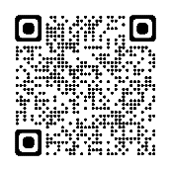 | Inclusive Dental - Bellarine Community Health  An award-winning inclusive dental service
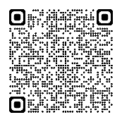 | Access for All Resources: Improving Accessibility  - Accessibility checklist (for your organisation to audit service access)  - Accessibility appointment guide  - Accessibility intervention guide  - Other resources
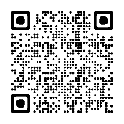 | The OneOneTwelve Initiative aims to recruit dental practitioners to take on individuals with special needs and manage their oral health for twelve months pro bono. This is inclusive of being provided support and training to support improving oral health and wellbeing outcomes.
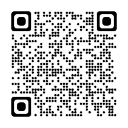 | Your Dental Health - Inclusion Melbourne includes:  - Oral Health and Intellectual Disability: A Guide for Dental Practitioners  - Oral Health and Disability in Children: A Guide for Oral Health Practitioners  - Inclusive practice videos for oral health practitioners
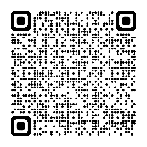 | Webinar recording: Oral health inclusive practice and the relationship between dentists and pharmacists 22.08.23 - YouTube (1h 1m 55s)
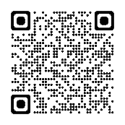 | Video recording: Specialist dentist involvement in case conferencing - YouTube (2m 16s)
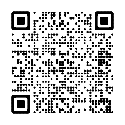 | DentiCare Case Studies (denticarepaymentplans.com.au)

