My health plan with the dentist
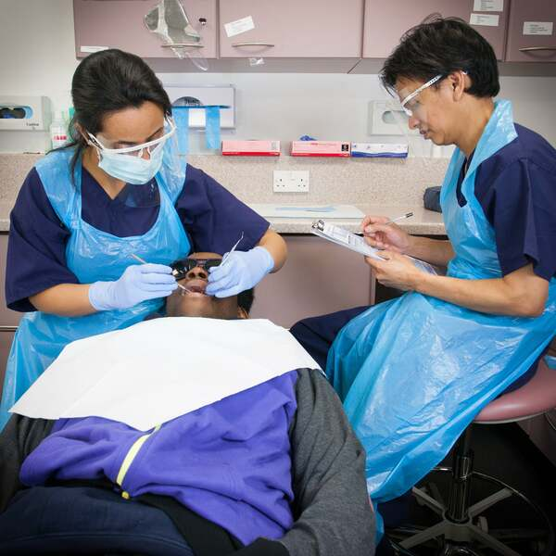 |  | This is my health plan with the dentist.  A dentist is a health professional that supports oral health which is the health of our teeth, mouth and gums.
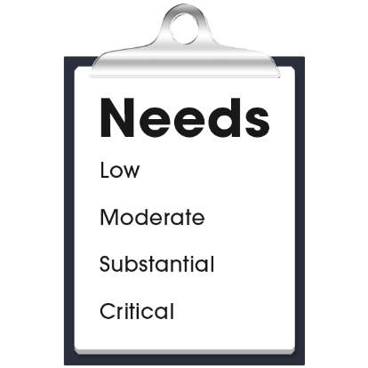 |  | My health care needs for my oral health are:  - (Nurse to add content)  - (Nurse to add content)  - (Nurse to add content)
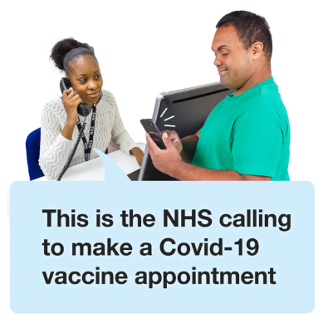 |  | The dentist contact details are:  - Name:  - Organisation:  - Phone:  - Email:  - Address:

My health plan with the dentist
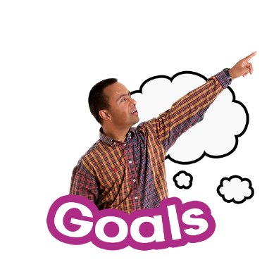 |  | My goals with the dentist:  - (Nurse to add content)  - (Nurse to add content)  - (Nurse to add content)
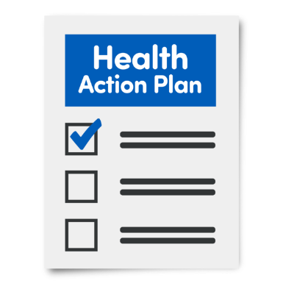 |  | My actions to support the health of my mouth and teeth:  - (Nurse to add content)  - (Nurse to add content)  - (Nurse to add content)
Next health appointment to check-up on this is:
(add time, date, location).

