My health plan with the diabetes nurse
This is my health plan with the diabetes nurse.

A diabetes nurse is a health professional that supports people to understand and manage diabetes.

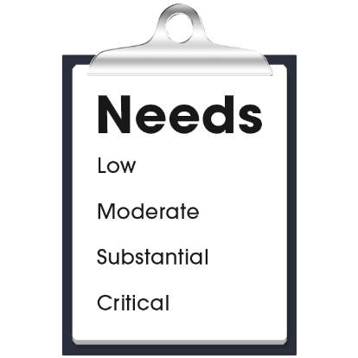 |  | My health care needs for diabetes are:  - (Nurse to add content)  - (Nurse to add content)  - (Nurse to add content)
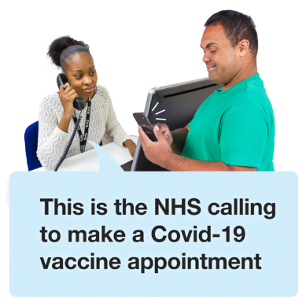 |  | The diabetes nurse contact details are:  - Name:  - Organisation:  - Phone:  - Email:  - Address:

My health plan with the diabetes nurse
My goals with the diabetes nurse:
- (Nurse to add content)
- (Nurse to add content)
- (Nurse to add content)

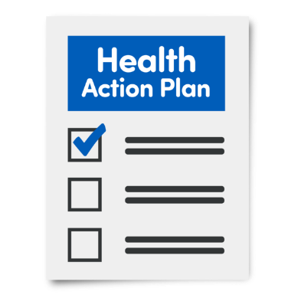 |  | My actions to support my diabetes:  - (Nurse to add content)  - (Nurse to add content)  - (Nurse to add content)
Next health appointment to check-up on this is:
(add time, date, location).

