My health plan with the dietitian
This is my health plan with the dietitian.

A dietitian is a health professional that looks at your diet and choosing good food and drinks.

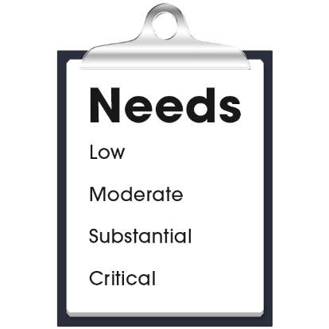 |  | My health care needs for my diet are:  - (Nurse to add content)  - (Nurse to add content)  - (Nurse to add content)
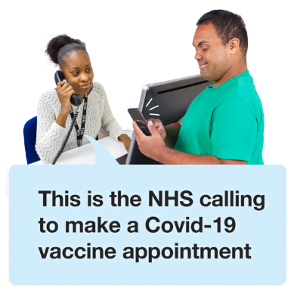 |  | The dietitian contact details are:  - Name:  - Organisation:  - Phone:  - Email:  - Address:

My health plan with the dietitian
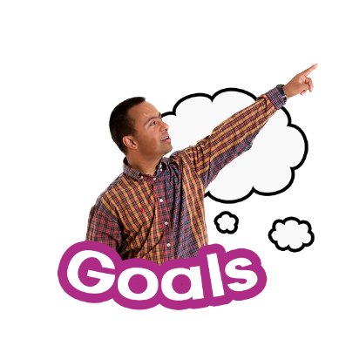 |  | My goals with the dietitian:  - (Nurse to add content)  - (Nurse to add content)  - (Nurse to add content)
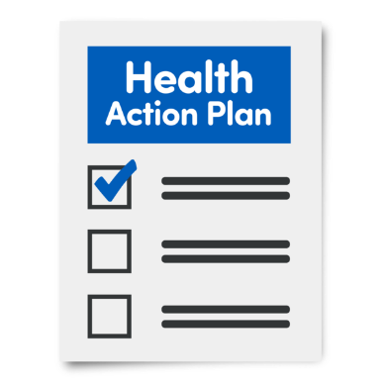 |  | My actions to look after my diet:  - (Nurse to add content)  - (Nurse to add content)  - (Nurse to add content)
Next health appointment to check-up on this is:
(add time, date, location).

