My health plan with the exercise physiologist
This is my health plan with the exercise physiologist.

An exercise physiologist is a health professional that supports physical activity and movement.

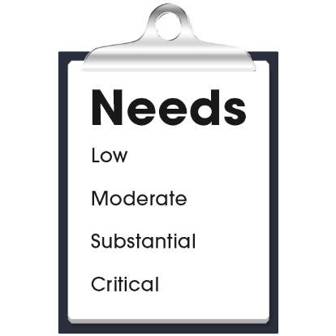 |  | My health care needs for physical activity are:  - (Nurse to add content)  - (Nurse to add content)  - (Nurse to add content)
The exercise physiologist contact details are:
- Name:
- Organisation:
- Phone:
- Email:
- Address:

My health plan with the exercise physiologist
My goals with the exercise physiologist:
- (Nurse to add content)
- (Nurse to add content)
- (Nurse to add content)

My actions to look after my physical activity:
- (Nurse to add content)
- (Nurse to add content)
- (Nurse to add content)

Next health appointment to check-up on this is:
(add time, date, location).

