My health plan with the occupational therapist
This is my health plan with the occupational therapist.

An occupational therapist is a health professional that looks at how people do everyday tasks and what supports they need.

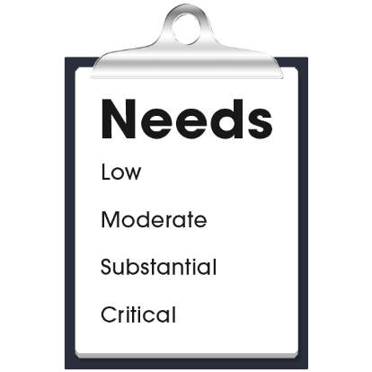 |  | My health care needs for everyday tasks are:  - (Nurse to add content)  - (Nurse to add content)  - (Nurse to add content)
The occupational therapist contact details are:
- Name:
- Organisation:
- Phone:
- Email:
- Address:

My health plan with the occupational therapist
My goals with the occupational therapist:
- (Nurse to add content)
- (Nurse to add content)
- (Nurse to add content)

My actions to support my everyday tasks:
- (Nurse to add content)
- (Nurse to add content)
- (Nurse to add content)

Next health appointment to check-up on this is:
(add time, date, location).

