Pharmacy Medication template
GP clinic details
Date (dd/mm/yyyy):
GP clinic name:
GP name:
Address:
Contact email:
Phone number:
My patient information
My name:
Date of birth (dd/mm/yyyy):
Address:
Contact email:
Phone number:
About me –
Please share – My usual style of communication is:
Please share – My living situation is (eg. Independently, supported accommodation):
Other information to share:

Note for health professional: Details to add in this document are dependent on the person’s communication styles and abilities.

Patient supporters
Note: It is important to have a key person or supporter in life. This may be a key worker, house supervisor or other (advocate, parent, sibling etc). Please provide their name and details so health professionals can talk directly to them, and they can give relevant information.
Patient supporter name:
Relationship:
Address:
Contact email:
Phone number:

Second patient supporter name:
Relationship:
Address:
Contact email:
Phone number:

Medication tips
Things to think about:
- Does this medication need to be taken before or after food?
- A certain time before bed or other?
- Consider the activities when taking medication as some medication can cause drowsiness.
- Monitor any side effects of the medication to keep track and report back to the GP.
- If the medication is causing serious side effects that are unbearable, report back to the GP.
- Make sure medication is taken as directed.
- Who needs to know about changes in medication – I.e. day placement staff, family etc.
- Sometimes it can take a few days or even a week or longer before the medication starts to work, ask the GP or pharmacist.

Medication
Note for health professional: If this medication is being prescribed as a restraint, please refer to the following Restrictive Intervention webpage for more information.

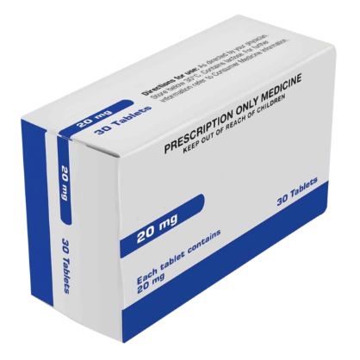 |  | Medication name:  Antipsychotic medication  Other medication names (if any):
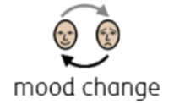  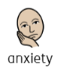 |  | What is this medication for:  - To treat anxiety, agitation, mood  problems, thinking and socialising  - Change from your usual behaviour  - Change in mood or emotions
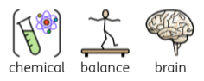 |  | The medication works by:  - Helping to restore chemical balance in the brain
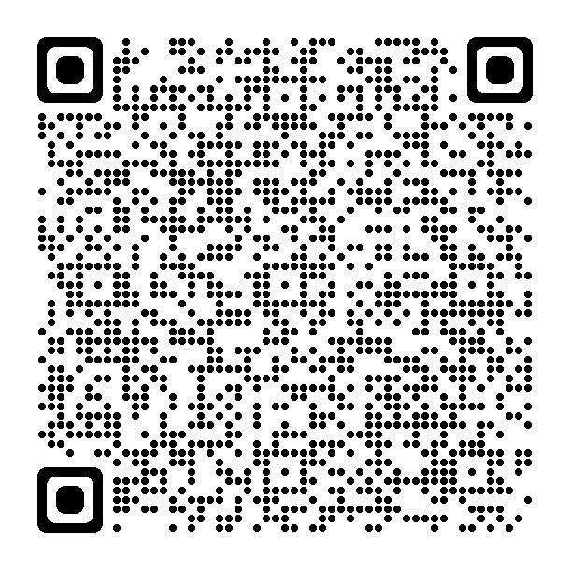 |  | Find out more about the medication here:  - Antipsychotic medications - Better Health Channel

Widgit Symbols © Widgit Software 2002-2023 www.widgit.com
Date medication started:
Date medication will finish:
Date for next GP visit for a new script:

Tips for your medication

- Monitor your health while you are on new medication.
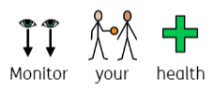
- Pick up more medication from the pharmacy.
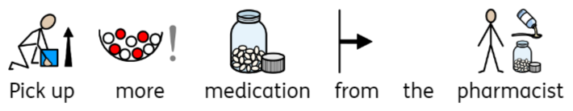
- Return to the GP if you are still unwell and let them know. This might be a face-to-face visit, or this may be a phone call where the doctor may be able to send another request for medication to the pharmacy.
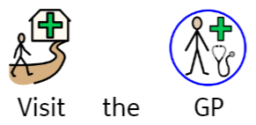
Widgit Symbols © Widgit Software 2002-2023 www.widgit.com

When is the medication to be administered and how much:
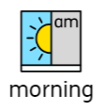  7.00am – 9.00am | (Add amount here and remove any times not needed)
11.00am – 2.00pm | 2 tablets after food
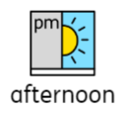
4.00pm – 6.00pm
8.00pm – 10.00pm
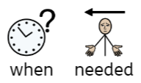
Widgit Symbols © Widgit Software 2002-2023 www.widgit.com
Risks
Urgent medical attention is required if the person experiences:
- Anaphylaxis, allergic reaction, rashes, airways closing
- Difficulty breathing
- Chest pain
(Note for pharmacist / health professional: Add any other relevant risks)

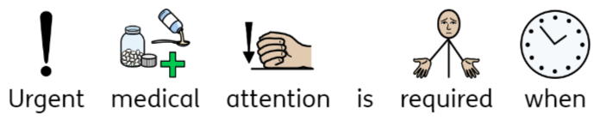

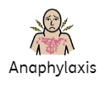
Tingling mouth
Swelling in your throat
Difficulty talking
Dizziness or collapsing

.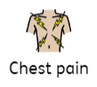
Widgit Symbols © Widgit Software 2002-2023 www.widgit.com
Possible side effects of medication
Possible side effects of medication
You may experience none, some, or all of the following side effects when you first start off on this medication. Keep track and monitor your health for any side effects.
Note for pharmacist / health professional: Copy common medication side effects (currently shown from pages 8 – 13) to this section so only relevant side effects for the medication are shown. Please add any additional side effects not listed.
Please delete any irrelevant content if not required for the patient. Remove this note once completed.
Widgit Symbols © Widgit Software 2002-2023 www.widgit.com

Common medication side effects Widgit Online – Terms and Conditions
Widgit Symbols © Widgit Software 2002-2023 www.widgit.com
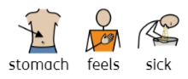 |  | - Upset stomach – Can make you feel like you want to be sick.
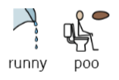 |  | - Diarrhea or loose stools – Can make your poo runny.
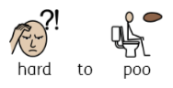 |  | - Constipation – You can have trouble having a poo because it’s hard and won’t come out.
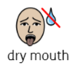 |  | - Dry mouth – can make you feel like you want to drink lots.

Common medication side effects continued
Widgit Symbols © Widgit Software 2002-2023 www.widgit.com
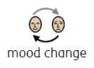 |  | - Change in activity or mood – can make you feel grumpy, angry or sad and sometimes can make you feel like crying but you’re not sure why.
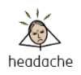 |  | - Headache – Your head can feel sore to touch or you can feel pain.
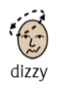 |  | - Dizziness – you may feel like your head is spinning.
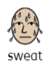 |  | - Flushing, sweating – Your face may go red, and you may feel very hot and uncomfortable.

Common medication side effects continued
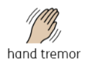 |  | - Tremors – your hands or other parts of your body may shake.
 |  | - Anxiety – Feeling worried or fearful.
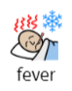 |  | - Fever – can have a high temperature, but you feel cold and shaky.
 |  | - Muscle pain- Your legs, arms and or body may feel sore and tired.
Widgit Symbols © Widgit Software 2002-2023 www.widgit.com

Common medication side effects continued
Widgit Symbols © Widgit Software 2002-2023 www.widgit.com
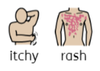 |  | - Rashes – Your skin can go red, feel itchy and bumpy to touch.
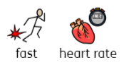 |  | - Rapid heartbeat – you can feel your heart thumping.
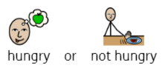 |  | - Changes in appetite – you may feel hungry, or you may not feel like eating at all.
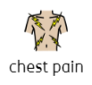 |  | - Heart issues – chest pain, heart palpitations, hard to breathe.

Common medication side effects continued
Widgit Symbols © Widgit Software 2002-2023 www.widgit.com
 |  | - Drowsiness – you may feel like you want to go to sleep.
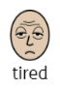 |  | - Fatigue – You may not feel like doing any of your normal activities because you feel very tired.
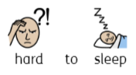 |  | - Sleep disturbances – You may not be able to get to sleep or stay asleep.
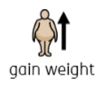 |  | - Weight gain – even though you haven’t changed what you eat, you may put on weight.

Common medication side effects continued
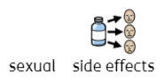 |  | - Sexual side effects.  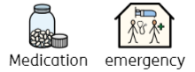
Medication emergency
(EASY READ)

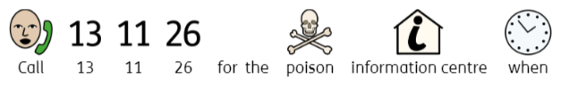
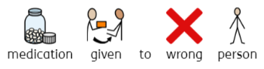
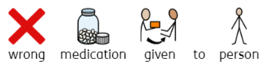
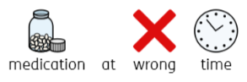

Widgit Symbols © Widgit Software 2002-2023 www.widgit.com
Medication emergency (EASY READ)
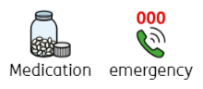
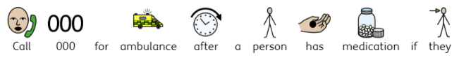
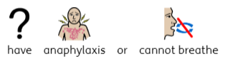
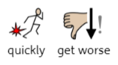
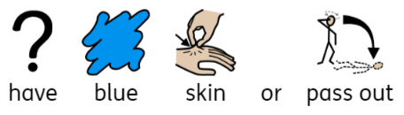
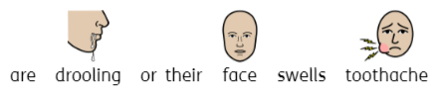

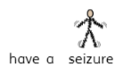
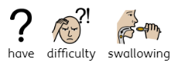

Widgit Symbols © Widgit Software 2002-2023 www.widgit.com

In emergencies

The Poisons Information Centre 13 11 26 should be called:
(24 hours a day, Australia wide)
- When medication is given to wrong person
- When the wrong medication is given to a person
- When the wrong dose is given (overdose)
- When a medication is given by the wrong route or using the wrong procedure
- When a medication is given at the wrong time and it results in an extra dose
- When a dose of medicine is missed

000 (triple zero) should be called:
(24 hours a day, Australia wide)
When you see signs of distress including:
- Loss of (or change in consciousness)
- Blue colour or difficulty breathing
- Difficulty swallowing
- Swelling of lips, tongue, or face, or drooling
- Seizure activity
- Rapidly spreading rash or hives
- Impaired speech or mobility
- Getting worse quickly
- When in doubt

The above content has been adapted from:
- Medication Side Effects & Reactions - HealthyChildren.org
- Victorian Poisons Information Centre - Better Health Channel

