My health plan with the physiotherapist
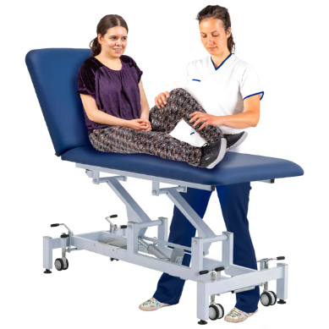 |  | This is my health plan with the physiotherapist.  A physiotherapist is a health professional that supports the way you move (movement) and how this can support you to do everyday tasks.
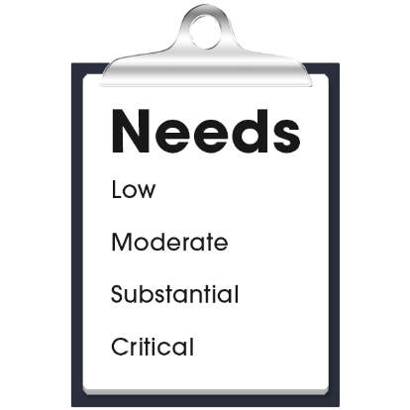 |  | My health care needs for movement are:  - (Nurse to add content)  - (Nurse to add content)  - (Nurse to add content)
The physiotherapist contact details are:
- Name:
- Organisation:
- Phone:
- Email:
- Address:

My health plan with the physiotherapist
My goals with the physiotherapist:
- (Nurse to add content)
- (Nurse to add content)
- (Nurse to add content)

My actions for my movement:
- (Nurse to add content)
- (Nurse to add content)
- (Nurse to add content)

Next health appointment to check-up on this is:
(add time, date, location).

