My health plan with the podiatrist
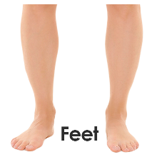 |  | This is my health plan with the podiatrist.  A podiatrist is a health professional that looks after feet and legs.
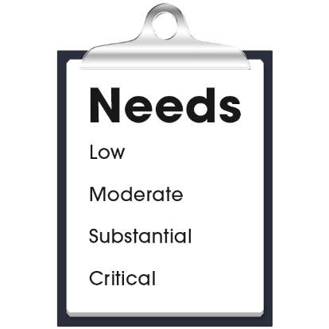 |  | My health care needs for my feet are:  - (Nurse to add content)  - (Nurse to add content)  - (Nurse to add content)
The podiatrist contact details are:
- Name:
- Organisation:
- Phone:
- Email:
- Address:

My health plan with the podiatrist
My goals with the podiatrist:
- (Nurse to add content)
- (Nurse to add content)
- (Nurse to add content)

My actions to look after my feet:
- (Nurse to add content)
- (Nurse to add content)
- (Nurse to add content)

Next health appointment to check-up on this is:
(add time, date, location).

