Signs and Symptoms Tracker
This Signs and Symptoms Tracker is recommended to monitor changes in your health. This can be used anytime and supports bringing the right information to the doctor (General Practitioner (GP)) so they can support your health and wellbeing.
You can add a photo here
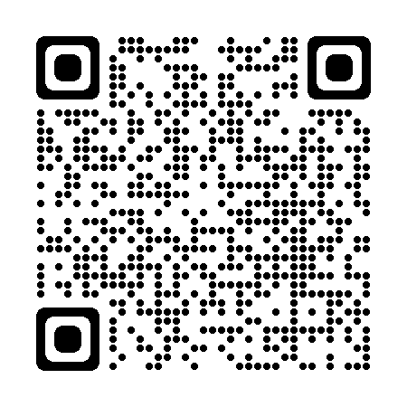
Either scan the QR code or click the link for:
How to Describe Medical Symptoms to Your Doctor: 14 Steps

This form
Date this form was completed (dd/mm/yyyy):
Organisation:
Name of person filling in this form:
Role / relationship:
Contact details:
Name of house supervisor:
Contact details:

Patient information
Name:
Date of birth (dd/mm/yyyy):
Other key information:

My GP
My GP clinic:
My doctor or GP:
Clinic phone number:
Quick summary of possible changes
Date of last GP visit (dd/mm/yyyy):
Date of last Annual Health Assessment (CHAP) (dd/mm/yyyy):

Has anything changed since your last GP visit: | Yes | No | If yes, please share more information
Have you had a medical emergency that required medical treatment? If yes, were you given new medication and what were the side effects?  Might this be causing the presenting problem? | ☐ | ☐
Have you been in hospital for any procedures? | ☐ | ☐
Have you had changes in your living arrangements?  For example, where you live or who you live with. | ☐ | ☐
Have you had changes in those that support you?  A supporter can be a key person in your life who knows the most about you. This may be a parent, key worker, house supervisor or other. | ☐ | ☐
Have you had changes in your regular routine?  For example, transition from school to work, employment or study. | ☐ | ☐
Have you stopped or reduced going out in the community? | ☐ | ☐
Consider:
- Your medical history (such as chronic conditions, trauma or past health concerns)
- Your family medical history (such as risk of chronic conditions or health concerns)
- Grief and loss - Has someone you know passed away recently
Tracking signs and symptoms
Date symptoms were first noticed (dd/mm/yyyy):
Please tick – Since signs and symptoms started:
☐ Symptoms are worse ☐ Symptoms are the same ☐ Symptoms are getting better
Monitor – When do the signs and symptoms occur?
See tracking chart over the page to support observation and monitoring. Please note, these tracking tools can assist the GP to understand if changes in either sleep patterns, weight gain or loss, or other things indicate possible serious health illnesses.
☐ Symptoms occur at same time of day
☐ Symptoms occur at various times
Monitor – Are there possible triggers that may cause the symptoms?
☐ After meals ☐ After medication ☐ Specific locations ☐ Sensory overload
Please share - Observations of possible triggers:

Monitor – Are there things that relieve the symptoms?
☐ Redirecting the person ☐ After medication ☐ Changing environment
Please share - Observations:

Resources for pain scale and other scales are attached.
Tracking body weight
Clients should see the doctor if there is a 5kg change in their weight within a 3-6 month period (this can be weight gain or weight loss).
Please complete the following:
Date weight taken | Body weight (kg) | Change in weight
Example: 12/03/2023 | 70.0kg
Example: 12/06/2023  (3 months later) | 76.0kg | Weight has increased by 6.0kg  (Alert the doctor)

Have you had a change of medication within the above period? ☐ Yes ☐ No

Tracking
You may consider tracking bowel movements, seizures, food and medication.
Asleep | Awake and calm | Medium levels of pain | High levels pain | Not in care (N/A)

 | 12am | 1am | 2am | 3am | 4am | 5am | 6am | 7am | 8am | 9am | 10am | 11am | 12pm | 1pm | 2pm | 3pm | 4pm | 5pm | 6pm | 7pm | 8pm | 9pm | 10pm | 11pm
Eg. |  |  |  |  |  |  |  |  |  |  |  |  | Meds
Day 1
2
3
4
5
6
7
8
9
10
11
12
13
14
15

Comments:

Has the person experienced change in the following body areas?
Has the person experienced changes in their: | Yes | No | If yes, please share more information:
Breathing system: The respiratory system takes up oxygen from the air we breathe. The main organ of the respiratory system is the lungs. Other respiratory organs include the nose, the trachea and the breathing muscles.
Breathing  Do they have difficulty breathing? Do they cough or wheeze? Do they easily run out of breath?  Might they be running a temperature, could they have a virus (COVID), the flu or anxiety? | ☐ | ☐
Nose  Do they have a runny nose? Blocked nose? Difficulty breathing? | ☐ | ☐
Heart system: The heart, blood and blood vessels work together to move oxygen and nutrients around your body.
Muscles and Joints: Bones, muscles and joints hold our body together and support body movement.
Gastrointestinal system: The digestive system turns food into nutrients that give the body energy. The mouth, oesophagus, stomach, small and large intestine, rectum and anus are involved.
Mouth  Do they have difficulty chewing or swallowing? Bad breath? Have they had changes in their teeth? | ☐ | ☐
Body weight  Have they put on weight? Or lost weight?  Track using tracking tool. | ☐ | ☐
Poo – its important to monitor bowel (poo) movement as it can tell the Doctor a lot about their health.
See the poo chart as below
Urinary system: The urinary system is made up of kidneys, bladder, ureters and the urethra. Many of the body’s waste products are passed out of the body in urine or wee.
Bowel and bladder habits  Do they have constipation or diarrhea? Are they going to the toilet more or less than normal? Do they take longer on the toilet than normal? Do they have pain or discomfort before, during or after going to the toilet? Is their blood in their poo?  Wee (see the urine chart as below)  Are they going to the toilet more or less than normal? Do they take longer on the toilet than normal? Do they have pain or discomfort before, during or after going to the toilet? | ☐ | ☐
Nervous system: The nervous system helps all the parts of the body to communicate with each other. It also reacts to changes both outside and inside the body. The nervous system uses both electrical and chemical means to send and receive messages.
Pain perception: Pain is our bodies built in alarm system. Pain can be acute, persistent or chronic.
How do they communicate pain?  Verbal language, some sign language, non-verbal communication styles such as gestures, vocalisations or even eye movements. | ☐ | ☐
Medications: Medications include prescription, over-the-counter and complementary or herbal treatments designed to help keep us well. Incorrect use of medicines can cause side effects, overdose and other reactions. Make sure you take your medicines correctly.
Have they had a recent change in medications?  Are they taking prescription medication? Are they having other medications? Are they taking any vitamins?  Could one of these medications be causing a side effect? | ☐ | ☐
Allergies: Allergies occur when our body overreacts to a 'trigger' or allergen. Common reactions include itchiness, sneezing and difficulty breathing. Anaphylaxis is a severe reaction that requires emergency treatment. Common allergies include hay fever, asthma, hives and food allergy.
Have they experienced allergies?  If yes, was the reaction severe and what were the symptoms?  Skin rash? Itchy eyes? Other allergic reactions? | ☐ | ☐
Sleep: Sleep is essential for your health. It refreshes the mind and repairs the body.
Sleeping  Are they sleeping more or less than normal? Are they having difficulty going to sleep or staying asleep? Are they struggling to get to of bed? | ☐ | ☐
Epilepsy: Epilepsy is a common condition of the brain in which a person has a tendency to have recurrent unprovoked seizures.
Seizures  Are they having seizures more or less than usual? Is it being treated?  Have these changes been captured on the monitoring chart? | ☐ | ☐
Sexual orientation and gender identity: Good sexual health is important for our overall health and wellbeing. It includes the right to healthy relationships, access to inclusive and safe health services, reliable information, and freedom from coercion, violence, stigma and discrimination.
Relationships: A ‘good relationship’ means different things to different people. However, good adult relationships generally involve two people who respect each other, can communicate, and have equal rights, opportunities and responsibilities.
Sexual activity  Are they touching certain parts of their body more often? Are there indicators that they have been scratching in and around their backside or genital area? | ☐ | ☐
Abuse  Do they have a history of abuse? Physical? Emotional? Psychological? Sexual?  Unexplained bruising, or restricted movement, bites, marks cuts or scratches, other | ☐ | ☐
Health of women and people with a cervix: This includes women’s sexual and reproductive health. See more information about health checks for women
Period (menstruation)  Do they have painful periods? Have there been any changes? If yes, might this relate to perimenopause? Or other  Moody, sleep disturbance, sore breast etc. | ☐ | ☐
Health of men and people with a penis: See more information about health checks for men
Behaviours of concern: Description: Agitated, physically, or verbally aggressive. Emotionally distressed, pacing, yelling, hearing, seeing, or feeling things that are not there.
Behaviour  Are they indicating behaviors of concern? If yes, might this relate to something physically being wrong or that they are mentally unwell? | ☐ | ☐
Mental health: Mental health description
Mental health indicator  Please tick what they experience -  ☐ Very worried or afraid most of the time  ☐ Feeling like you may vomit.  ☐ Suicidal ideation/thoughts/actions  ☐ Self-harm  ☐ Self-blame and/or inappropriate guilt  ☐ Loss of self-care skills  ☐ Other (please add more information) | ☐ | ☐
Vision: Vision impairments impact a person’s ability to see.
Any problems with the eyes?  Do they have difficulty seeing? Do they have red puffy eyes? Do they have bags under their eyes? | ☐ | ☐
Hearing: Hearing impairments impact a person’s ability to hear.
Hearing  Has their hearing changed, are they having difficulty hearing? | ☐ | ☐
Activity and lifestyle: Healthy Eating Pyramid
Eating  Are they eating more or less than normal? Do they have difficulty swallowing? Have they been vomiting?  Might it be related to not eating enough healthy foods | ☐ | ☐
Physical  Have they had any problems with walking or reduced their physical activity? If yes, might there be a problem with their feet (shoes rubbing), itchy feet (tinea) aching muscles, feeling tired (lack of sleep)? | ☐ | ☐
Everyday abilities  Have they stopped doing activities they really like?  Either at home, day placement or both?  Change in mood, feeling out of sorts | ☐ | ☐
Social activities  Are they withdrawing from social activities they used to participate in? | ☐ | ☐
Communication  Has their ability to communicate their needs changed? If yes, could they have an ulcer, sore throat, tooth ache. | ☐ | ☐
Memory  Have they had a sudden change memory? Might this be related to: depression, an infection, or medication side effect? | ☐ | ☐

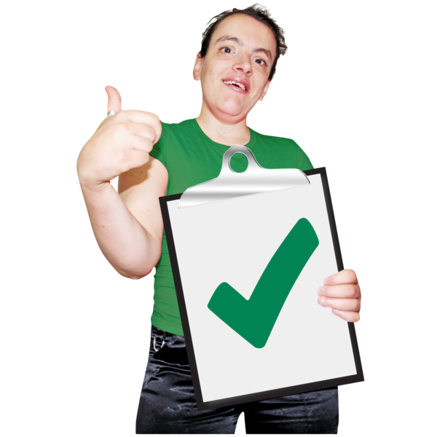
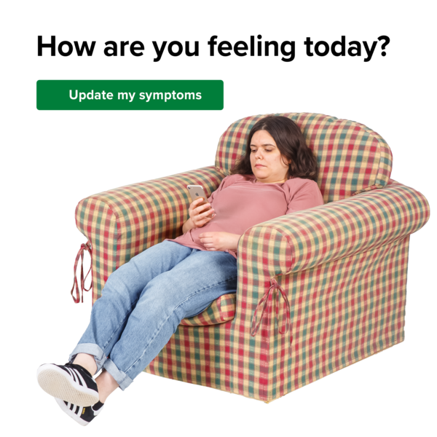

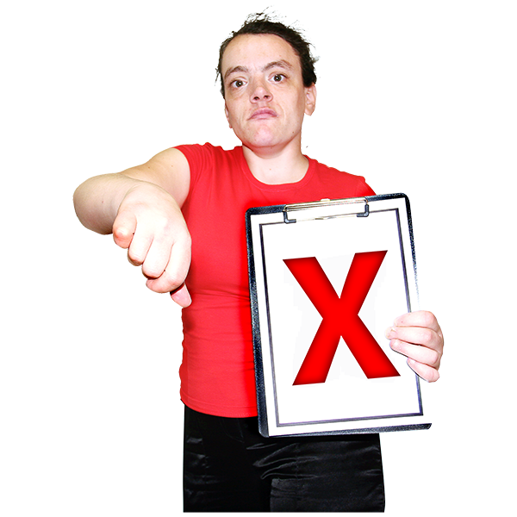
Good
Bad

This ‘How do you feel today?’ image was accessed from the Teachers Mag website: "How Do You Feel Today," Emotion Expression Worksheets.

This stool chart was accessed from the Continence Australia website: https://www.continence.org.au/bristol-stool-chart 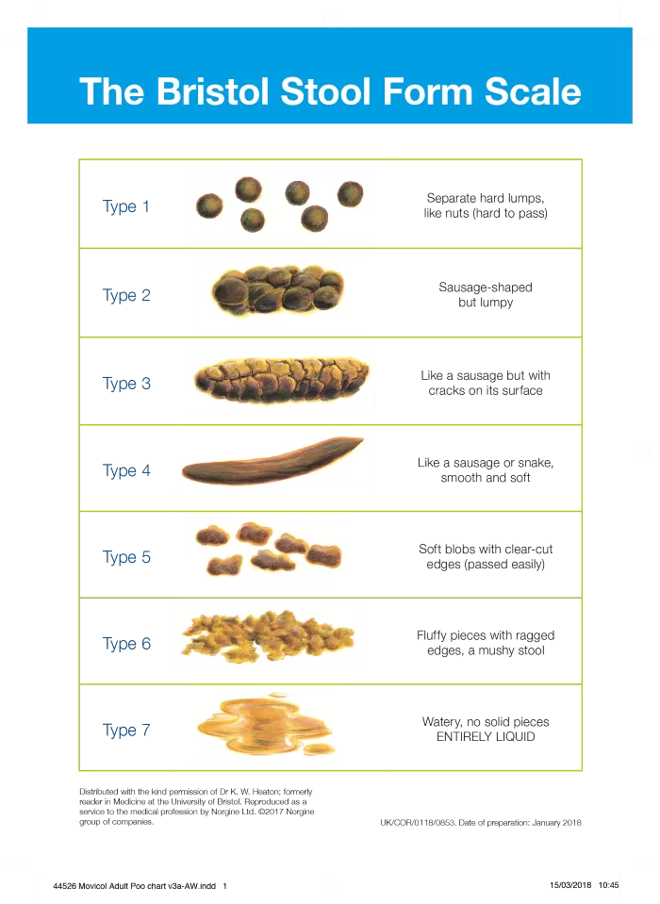

This urine colour chart was access from the Health Direct website: https://www.healthdirect.gov.au/urine-colour-chart
