My health plan with the speech pathologist
This is my health plan with the speech pathologist.

A speech pathologist is a health professional that looks at how people communicate and can treat people with swallowing difficulties.

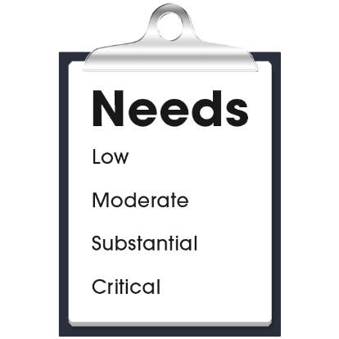 |  | My health care needs for communication are:  - (Nurse to add content)  - (Nurse to add content)  - (Nurse to add content)
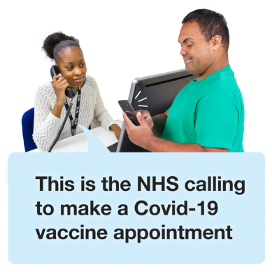 |  | The speech pathologist contact details are:  - Name:  - Organisation:  - Phone:  - Email:  - Address:

My health plan with the speech pathologist
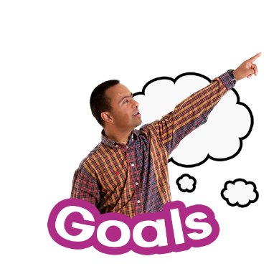 |  | My goals with the speech pathologist:  - (Nurse to add content)  - (Nurse to add content)  - (Nurse to add content)
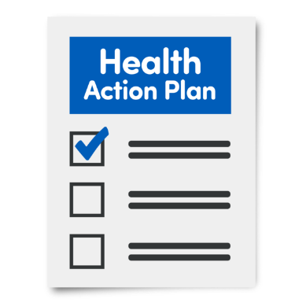 |  | My actions to support my communication:  - (Nurse to add content)  - (Nurse to add content)  - (Nurse to add content)
Next health appointment to check-up on this is:
(add time, date, location).

